**NAME**: DEVJYOTI KARAN

**REG. NO**.: 19BCE0690 **SLOT**: L47+L48

**CSE 3001 SOFTWARE ENGINEERING**

**Test report and exploration of conf. mgt. tools**

|  |  |  |
| --- | --- | --- |
| TEST CASES(COMMENTS) | OUTPUT | EXPECTED OUTPUT |
| He graded a 100 level class like we were all English majors in a 300 or above level class. Never got higher than a C on a paper. I went to the writing center for every paper. Very unclear in instructions and hard to approach with questions. Don't take the class from him. | Poor/Rating:2 | Poor/Rating:2 |
| This was a tough class. I expected all college classes to be like this, but since most are not it was somewhat refreshing to have a professor push me this much. If you are willing to put in the work for Mr. Rand you will reep the benefits. If not, then take this class from someone else. | Good/Rating:4 | Average/Rating:3 |
| Farm is a fantastic guy that is very easy to get along with. Greets you with a smile every day and is excited to see you each and every day and tries to make the class fun. Defenitly introduce yourself to him. He is confusing in his explaining of concepts. He tends to over-explain where it gets confusing. He is a very respectable person. | Average/Rating:3 | Average/Rating:3 |
| Gives easy examples in class when teaching, then when it comes to web assign homework its harder stuff that he never taught, only teaches the basic examples and expects you to take it from there on your own. | Awful/Rating:1 | Awful/Rating:1 |
| Very entertaining. Keeps you engaged! He connects things to real world stuff so it's easy to understand which makes the tests easy! | Awesome/Rating:5 | Awesome/Rating:5 |
| This guy is hilarious and definitely knows what he is talking about. By far the best sociology teacher and is very easy and fun to listen to | Awesome/Rating:5 | Awesome/Rating:5 |
| His tests for the intro to anatomy and physiology class were ridiculously hard. He gives you a study guide but that doesn't really help you. His multiple choice tests are A-F sometimes A-J. After the second test with a class average of 50% or lower it really discouraged people to even try. His questions are tricky and sometimes out of context. | Awful/Rating:1 | Awful/Rating:1 |
| Yes, the tests are hard, it's a lot of work, but it's the most rewarding class ever. Shively is GREAT in lecture because he gives you simple definitions. The best textbook I've ever had. Grading is rough, but you'll understand why. He lets you know what you do need to know and in how much detail. He comes off scary but he's hilarious & very sweet. | Awesome/Rating:5 | Awesome/Rating:5 |
| If you do not have a job, and all you do is school, this class may be slightly easier for you. But it would be a lie to say he is a good teacher, or grades fairly. The study guides, and going to class contained maybe 10% of what is actually on the tests. The average test scores are around 35%. | Poor/Rating:2 | Poor/Rating:2 |
| Oh man, where do I begin? Great charisma and absolutely loves what he teaches. Should teach more feild classes! Real fun and easy going, will work with you if you need it too. Would take future classes if I could. | Awesome/Rating:5 | Awesome/Rating:5 |

Output matches expected ouput 9 out of 10 times. More than 90% accuracy was achieved.

**Screenshots of Outputs**

He graded a 100 level class like we were all English majors in a 300 or above level class. Never got higher than a C on a paper. I went to the writing center for every paper. Very unclear in instructions and hard to approach with questions. Don't take the class from him.

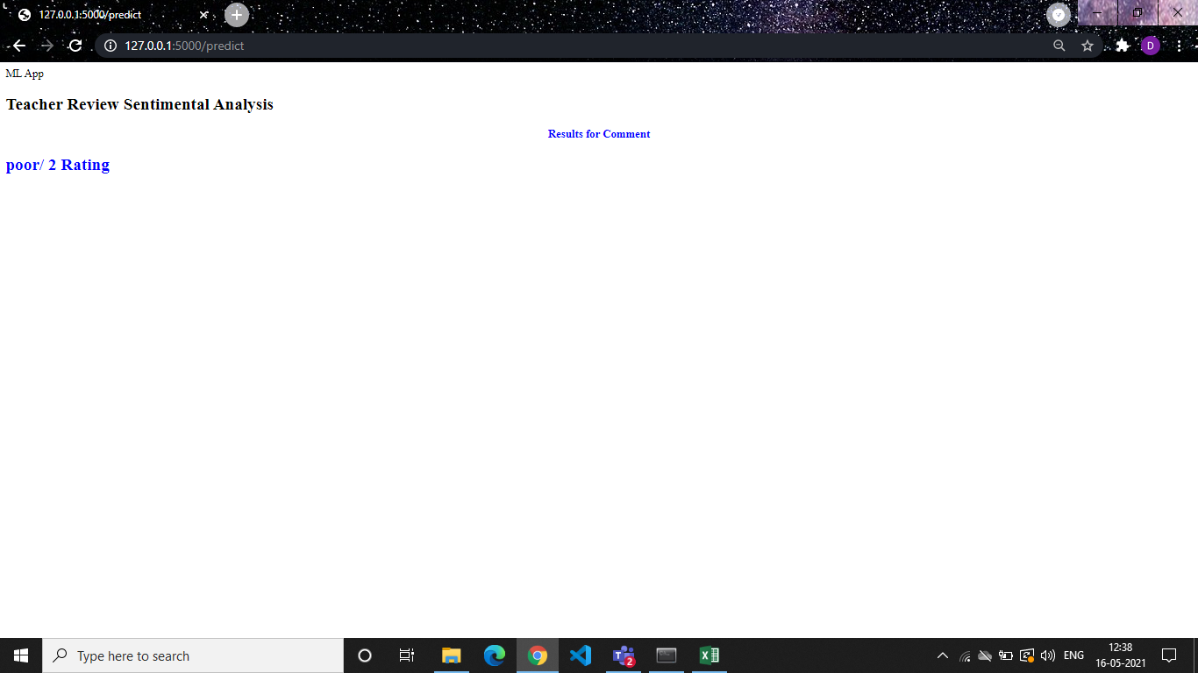

This was a tough class. I expected all college classes to be like this, but since most are not it was somewhat refreshing to have a professor push me this much. If you are willing to put in the work for Mr. Rand you will reep the benefits. If not, then take this class from someone else.

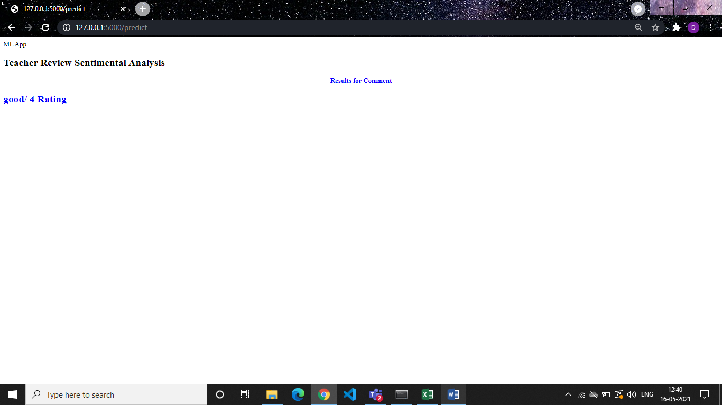

Farm is a fantastic guy that is very easy to get along with. Greets you with a smile every day and is excited to see you each and every day and tries to make the class fun. Defenitly introduce yourself to him. He is confusing in his explaining of concepts. He tends to over-explain where it gets confusing. He is a very respectable person.

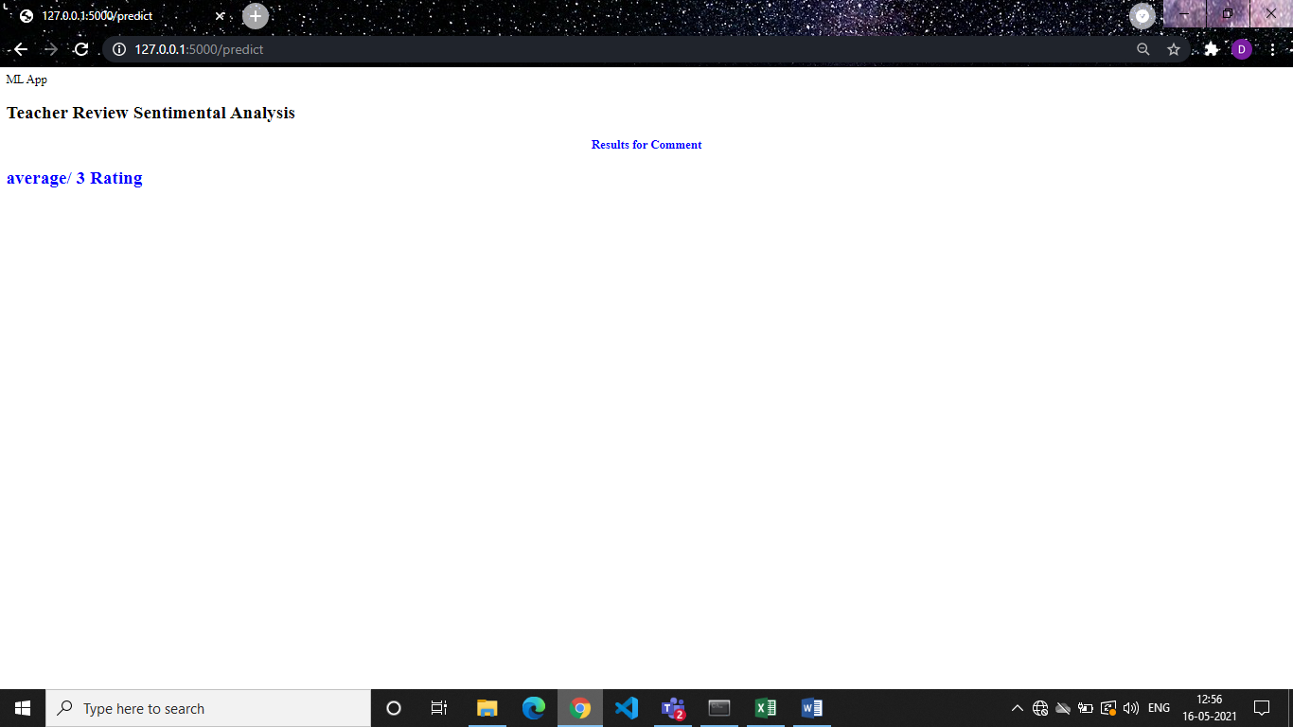

Gives easy examples in class when teaching, then when it comes to web assign homework its harder stuff that he never taught, only teaches the basic examples and expects you to take it from there on your own.

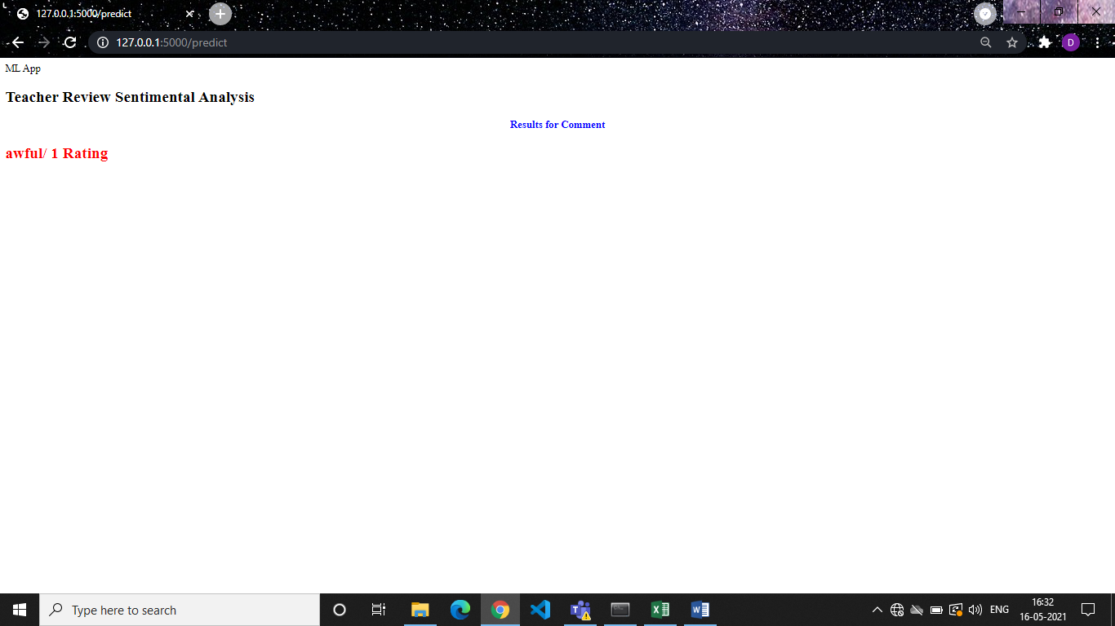

Very entertaining. Keeps you engaged! He connects things to real world stuff so it's easy to understand which makes the tests easy!

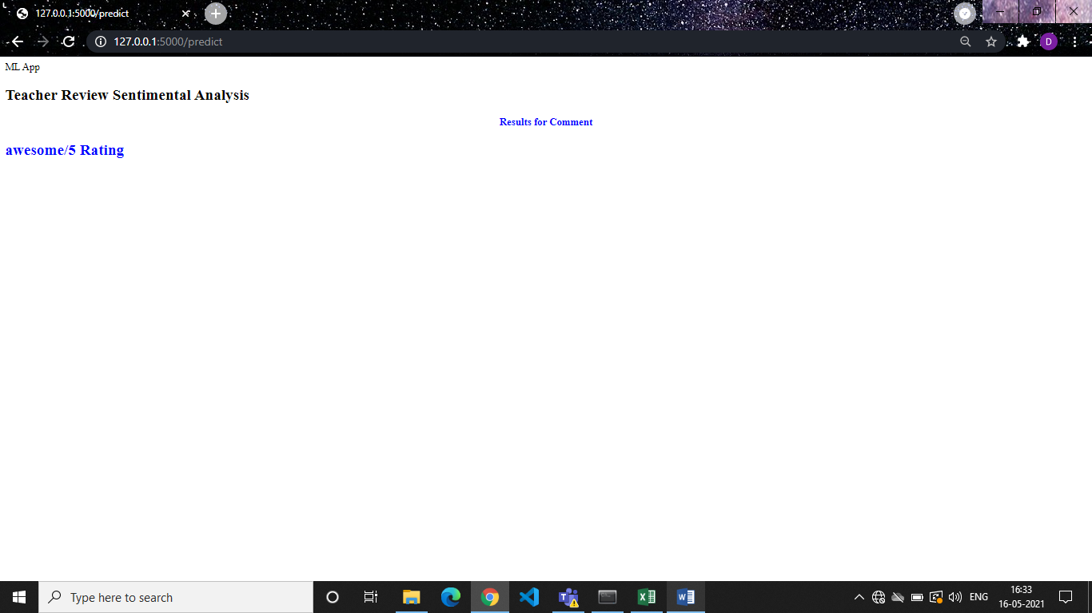

This guy is hilarious and definitely knows what he is talking about. By far the best Sociology teacher and is very easy and fun to listen to



His tests for the intro to anatomy and physiology class were ridiculously hard. He gives you a study guide but that doesn't really help you. His multiple choice tests are A-F sometimes A-J. After the second test with a class average of 50% or lower it really discouraged people to even try. His questions are tricky and sometimes out of context.

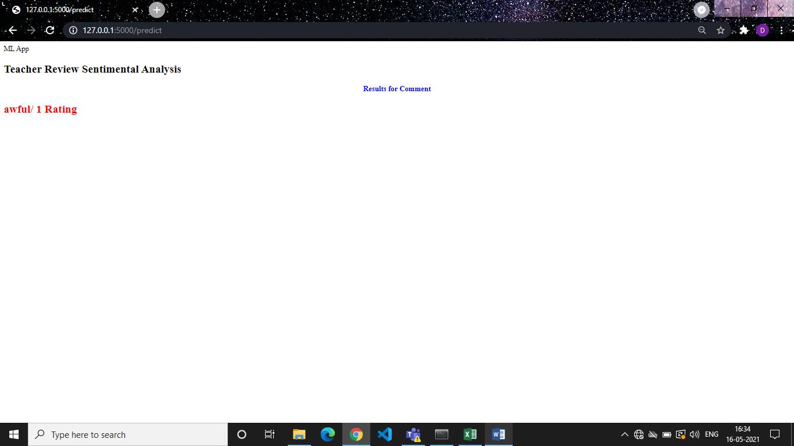

Yes, the tests are hard, it's a lot of work, but it's the most rewarding class ever. Shively is GREAT in lecture because he gives you simple definitions. The best textbook I've ever had. Grading is rough, but you'll understand why. He lets you know what you do need to know and in how much detail. He comes off scary but he's hilarious & very sweet.

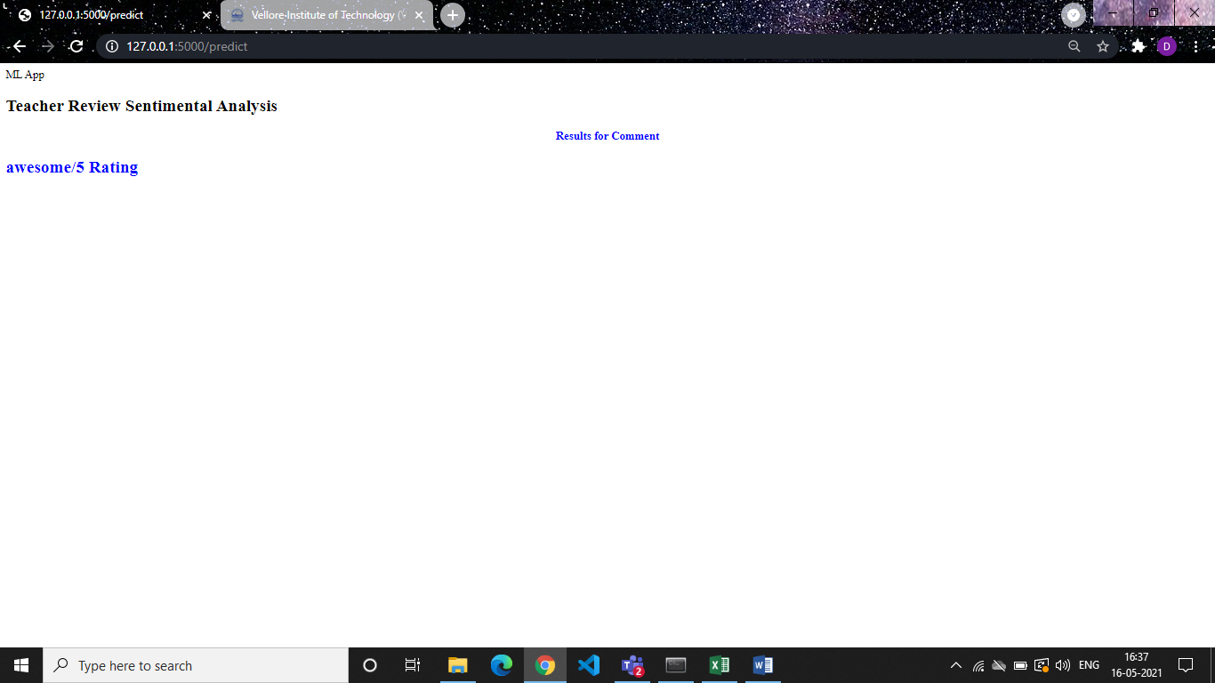

If you do not have a job, and all you do is school, this class may be slightly easier for you. But it would be a lie to say he is a good teacher, or grades fairly. The study guides, and going to class contained maybe 10% of what is actually on the tests. The average test scores are around 35%.

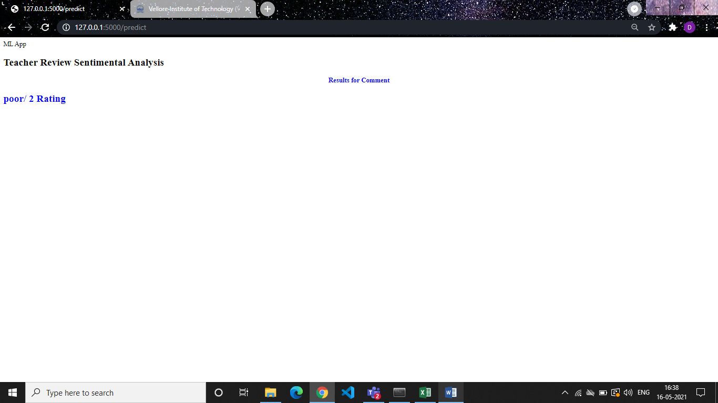

Oh man, where do I begin? Great charisma and absolutely loves what he teaches. Should teach more feild classes! Real fun and easy going, will work with you if you need it too. Would take future classes if I could.

